**Number Theory in Mathematics**

**Number Theory** is the branch of mathematics that deals with the study of positive numbers and arithmetic operations based on them. Numbers are the mathematical entities that are used for counting. Since the development of human civilization, numbers have always been a source of fascination for various mathematicians across the globe.

In this article on Number Theory, we will learn about **what is number theory, the history of number theory, the number system, types of numbers, operations on numbers, arithmetic operations, and many more in detail.**

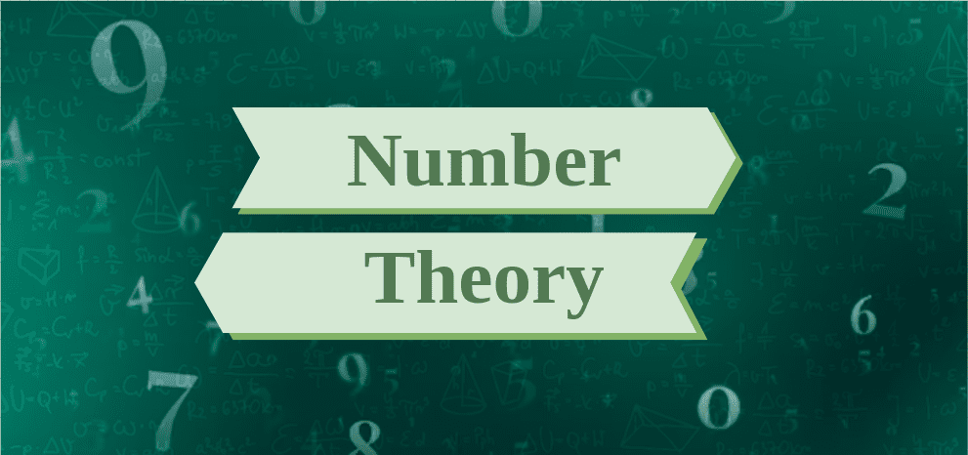

**What is Number Theory?**

Number theory is a branch of mathematics that deals with the properties and relationships of numbers, particularly integers. It explores patterns, structures, and properties of numbers and seeks to understand their fundamental properties and behaviors.

Key topics in number theory include prime numbers, divisibility, modular arithmetic, Diophantine equations, and the distribution of prime numbers. Number theory has applications in various fields such as cryptography, computer science, and physics, and it plays a foundational role in many areas of mathematics.

**History of Number Theory**

[Number](https://www.geeksforgeeks.org/numbers/)theory, originating in ancient Mesopotamia circa 1800 BC with Plimpton 322’s discovery, encompasses Pythagorean triplets and Babylonian astronomy.

Pythagoras furthered this with his triplets, influencing Euclid’s postulates in geometry and arithmetic. Indian mathematicians like Aryabhatta and Brahmagupta made key contributions, while the European Renaissance saw Pierre De Fermat’s perfect numbers and prime theory, and Leonhard Euler’s analytical number theory.

Lagrange and Legendre refined prime number theory, and Carl Friedrich Gauss advanced quadratic reciprocity and computational methods. These efforts shaped modern number theory, impacting diverse mathematical fields and practical applications.

**Branches of Number Theory**

Number theory is vast and diverse, thus to understand it better it is classified into various sub branches given in the following table:

| **Branch** | **Description** |
| --- | --- |
| **Elementary Number Theory** | Studies basic properties of integers like divisibility, primes, factorization, and congruences. |
| **Analytic Number Theory** | Applies tools from analysis to study the distribution of prime numbers and other number-theoretic functions. |
| **Algebraic Number Theory** | Investigates algebraic structures involving number fields, rings of integers, and algebraic integers. |
| **Diophantine Equations** | Focuses on finding integer solutions to polynomial equations, such as Fermat’s Last Theorem. |
| **Additive Number Theory** | Studies properties of additive structures within integers, including partitions and arithmetic progressions. |
| **Multiplicative Number Theory** | Focuses on multiplicative properties of integers, such as multiplicative functions and the distribution of primes. |

**Number System**

The [**number system**](https://www.geeksforgeeks.org/number-system-in-maths/) is a system for representing numbers on the Number Line in Number Theory using a collection of symbols and rules. These symbols, which run from 0 to 9, are referred to as digits. The [Number System](https://www.geeksforgeeks.org/number-system-in-maths/)is used to conduct mathematical computations ranging from complex scientific calculations to simple counting of Toys for a Kid or the number of chocolates left in the box.

**Types of Number System**

Numbers can be written in different bases and various forms. The different [types of number systems](https://www.geeksforgeeks.org/how-many-types-of-number-systems-are-there/) are mentioned below:

| **Number System** | **Description** |
| --- | --- |
| **Decimal Number System** | Base 10 representation using digits 0 to 9. |
| **Binary Number System** | Base 2 representation using digits 0 and 1. |
| **Octal Number System** | Base 8 representation using digits 0 to 7. |
| **Hexadecimal Number System** | Base 16 representation using digits 0 to 9 and letters A to F. |
| **Roman Number System** | Ancient system using letters: I (1), V (5), X (10), L (50), C (100), D (500), M (1000). Other numbers are represented using combinations of these letters. |

***Note:*** *We can also interconvert these numbers from one form to other form of number system.*

**Types of Numbers**

Numbers are classified into various categories based on their properties. Let’s learn the various types of numbers.

| **Type** | **Description** | **Examples** |
| --- | --- | --- |
| [**Natural Numbers**](https://www.geeksforgeeks.org/what-are-natural-numbers/) | Counting numbers starting from 1, denoted by N, including positive integers. | 1, 2, 3, 4, 5, . . . |
| [**Whole Numbers**](https://www.geeksforgeeks.org/what-are-whole-numbers/) | Natural numbers including zero, denoted by W. | 0, 1, 2, 3, 4, . . . |
| [**Integers**](https://www.geeksforgeeks.org/integers/) | Whole numbers along with their negatives and zero, denoted by Z. | . . ., -3, -2, -1, 0, 1, 2, 3, . . . |
| [**Rational Numbers**](https://www.geeksforgeeks.org/what-are-rational-numbers/) | Numbers expressible as a ratio of two integers, denoted by Q. | 1/2​, 3/4. 7/3 . . . |
| [**Irrational Numbers**](https://www.geeksforgeeks.org/irrational-numbers/) | Numbers that cannot be expressed as a ratio of two integers, often with non-repeating, non-terminating decimals. | √2​, *π*, *e*, . . . |
| [**Real Numbers**](https://www.geeksforgeeks.org/real-numbers/) | Union of rational and irrational numbers, representing all points on the number line, denoted by R. | -3.14, 0, 2.718, √3​, . . . |
| [Imaginary Numbers](https://www.geeksforgeeks.org/imaginary-numbers/) | Numbers of the form *bi*, where *b* is a non-zero real number and *i* is the imaginary unit. | 2*i*, −3*i*, 1/2​*i*, . . . |
| [**Complex Numbers**](https://www.geeksforgeeks.org/complex-numbers/) | Numbers of the form *a*+*bi*, where *a* and *b* are real numbers, and *i* is the imaginary unit, denoted by C. | 3+4*i*, 2−*i*, −1+2*i*, . . . |

**Numbers based on Divisibility**

A number may be divisible by a certain number or may not be divisible a certain number. Hence based on divisibility they can be classified as follows:

| **Type** | **Description** | **Examples** |
| --- | --- | --- |
| [Prime Numbers](https://www.geeksforgeeks.org/prime-number/) | Natural numbers greater than 1 with no positive divisors other than 1 and itself. | 2, 3, 5, 7, 11, 13, 17, … |
| [Composite Numbers](https://www.geeksforgeeks.org/composite-numbers/) | Natural numbers greater than 1 that are not prime, having divisors other than 1 and itself. | 4, 6, 8, 9, 10, 12, 14, … |
| [Odd Numbers](https://www.geeksforgeeks.org/odd-numbers/) | Integers not divisible evenly by 2. | -3, -1, 1, 3, 5, 7, … |
| [Even Numbers](https://www.geeksforgeeks.org/even-numbers/) | Integers divisible evenly by 2. | -4, -2, 0, 2, 4, 6, … |

**What is Arithmetic?**

**Arithmetic** is a field of mathematics that studies the characteristics of classical operations on numbers, such as addition, subtraction, multiplication, division, exponentiation, and root extraction.

Arithmetic is a fundamental aspect of number theory, which, along with algebra, geometry, and analysis, is regarded as one of the premieres of modern mathematics. The phrases arithmetic and higher arithmetic were used as synonyms for number theory until the early twentieth century, and are now occasionally used to refer to a wider section of number theory.

**Read More:**[**Arithmetic**](https://www.geeksforgeeks.org/math-arithmetic-what-is-arithmetic/)

**Arithmetic Operations**

There are four basic arithmetic operations addition, subtraction, multiplication and division. These operations are helpful in daily life calculations as well as complex calculations. The four basic operations are discussed below:

| **Operation** | **Description** | **Symbol** | **Example** |
| --- | --- | --- | --- |
| **Addition** | Combining two or more numbers to find their sum. | + | 5 + 3=8 |
| **Subtraction** | Finding the difference between two numbers. | – | 9 − 4 = 5 |
| **Multiplication** | Repeated addition; finding the product of two numbers. | ×, * | 2 × 6 = 12 |
| **Division** | Sharing or partitioning a quantity into equal parts. | ÷, / | 12 ÷ 3 = 4 |
| **Exponentiation** | Repeated multiplication; raising a number to a power. | ab | 23 = 8 |
| **Square Root** | Finding the number which, when multiplied by itself, gives the original number. | √ | √(16) =4 |

**Applications of Arithmetic**

Arithmetic has got numerous applications in our daily lives. The above-discussed arithmetic operations are used to solve various types of arithmetic operations. Following are the related articles that define the applications of arithmetic.

**Properties of Numbers**

The numbers follow various properties. These properties are closure property, commutative property, associative property, distributive property, identity property, and inverse property. These properties are defined for different numbers and different operations.

| **Property** | **Description** | **Example** |
| --- | --- | --- |
| **Closure Property** | The result of an operation on two numbers from a set is also a member of that set. | Addition: 2+3=5 is a member of the set of integers. |
| **Commutative Property** | Changing the order of operands in an operation does not change the result. | Addition: 2+3=3+2 |
| **Associative Property** | Changing the grouping of operands in an operation does not change the result. | Addition: (2+3)+4=2+(3+4) Multiplication: (2×3)×4=2×(3×4) |
| **Identity Property** | The result of an operation with a specific identity element and any number remains the same. | Addition: 5 + 0 = 0 + 5=5 |
| **Inverse Property** | For every element, there exists an inverse element such that their sum is the identity element. | Addition: 5+(−5)=0 |
| **Distributive Property** | The operation distributes over addition or subtraction. | Multiplication over addition: 2×(3+4)=2×3+2×4 |

**Applications of Number Theory**

Arithemtic has got wide range of applications in mathematics from finding the factors and multiples of a number to calculate the compounding value of money. Let’s learn the different applications of Arithmetic in brief.

**Place Value and Face Value**

Place Value and Face Value are important component a digit in a Number. Face Value is the the value by which a digit is recognised in mathematics irrespective of its position. For Example, in 5, 58, 568, the Face value of 5 is always five. However, the place value is the value of a digits due to its position. Place value is obtained by multiplying face value of number with its position. For example, in 5 the place value of 5 is 5 × 1 = 5 as 5 is in ones place. In 58, the place value of 5 is 5 × 10 = 50 as 5 is in tens place.

The place value also varies from indian system to international system. In Indian system the place value in increasing order is given as Ones, Tens, Hundred, Thousand, Ten Thousand, Lakh, Ten Lakh, Crore, Ten Crore etc.

**Factors and Multiples**

A number is said to be a factor of other number if it divides other number exactly. The other number which gets divided is called Multiple. If the all the factors are prime, then the method is called Prime Factorization. Factors and Multiples has got application in Number Theory to find HCF and LCM of two or more numbers which are used in arithmetic Problems.

* [*HCF and LCM*](https://www.geeksforgeeks.org/hcf-and-lcm/)
* [*Fundamental Theorem of Arithmetic*](https://www.geeksforgeeks.org/fundamental-theorem-of-arithmetic/)

**Divisibility Rules**

[Divisibility Rules](https://www.geeksforgeeks.org/divisibility-rules/) are important to find with what numbers a number is divisible. Since, it is very difficult to divide and check if a given number is divisible by particular number or not, here divisibility rules comes as a saviour to make the calculation easy.

**Exponents**

In Theory of Numbers we come across numbers which are raised to some powers, for example, 23 where 2 is called the base and 3 is called the exponent. Exponents are used in Number Theory to represent very large numbers such as distance between two celestial bodies and also very small numbers such as mass of an atom. The problems involving exponents are solved using laws of exponents.

* [*Laws of Exponents*](https://www.geeksforgeeks.org/what-are-the-7-laws-of-exponents/)
* [*Negative Exponents*](https://www.geeksforgeeks.org/negative-exponents/)

**Roots**

We know that exponents are the used to represent large numbers. But in case we have a large number which is a result of exponent raised to some base. This base is called Root of the Number. We often come across problems involving square root and cube root. To solve these questions we need to learn the concept of roots.

* [*nth roots of a number*](https://www.geeksforgeeks.org/nth-roots/)
* [*Squares and Square Roots*](https://www.geeksforgeeks.org/squares-and-square-roots/)
* [*Cubes and Cube Roots*](https://www.geeksforgeeks.org/cubes-and-cube-roots/)

**Logarithms**

In Number Theory, [Logarithm](https://www.geeksforgeeks.org/logarithms/) is used to find the exponent for which a number is raised to give a certain certain result. For Example, 23 = 8, in this case, the base 2 can be find out using the concept of roots but the power to which 2 is raised to give 8 as result can be find out using the concept of logarithms. The reverse process of logarithm is called Antilog. Logarithm is valid only for positive numbers.